System architecture

System architecture is based on MCV architecture and it has 4 packages like is shown on a picture below. Packages are: Client – contains application clients (web and mobile), Server – Application server – application server, ensures application functionality, Data – ensure data storage, 3rd Party Components – Google and Facebook APIs.

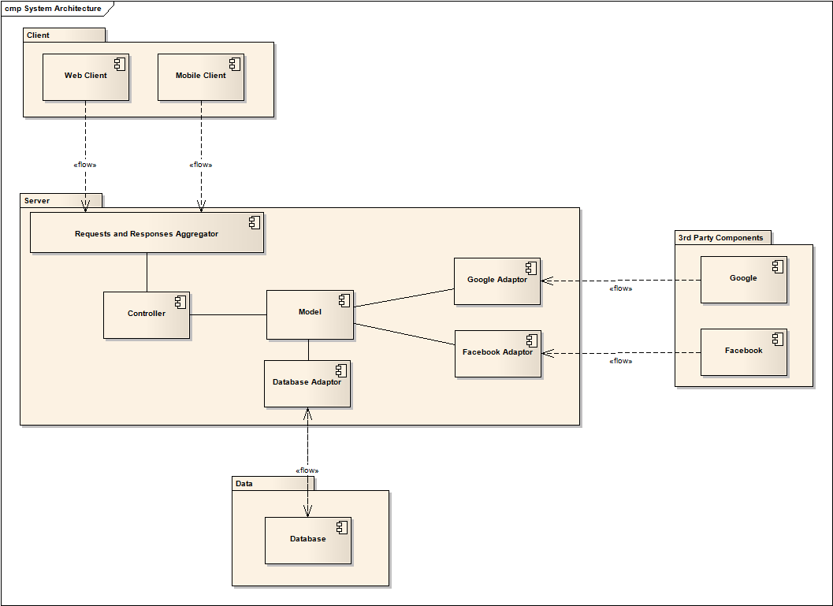
Fig 1.0 – System Architecture

Describe of single components of architecture:
Client: Web Client, Mobile Client
Server: Requests and Responses Aggregator - Aggregates requests from web application and mobile application and sends it do Application core (Controller). Includes Access Control in Component Model.
Controller - Application total core - manages all operations and sets Model.
Model - Holds all application logic, model, states and data. Includes Places, Map and Forum.
Database Adaptor - Solves information and data gap between Database and Model.
Google Adaptor - Adapts Google API for application in way that any query will be easier to make. Includes Google Maps adaptor and Google Places adaptor.
Facebook Adaptor - Adapts Facebook API for application in way that any query will be easier to make.
Data: Database – Database server
3rd Party Components: Google - Google API for handling Maps and Places from Google.
Facebook - Facebook API for handling Facebook places.

Deployment diagram

Deployment model shows which parts of system runs on which devices.

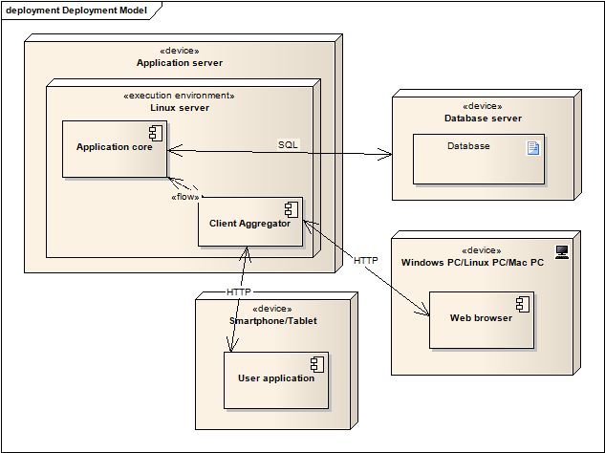
Fig 1.1 - Deployment diagram

Describe of Deployment diagram:
Application server - Application Machine – server
Linux server - Application Environment
Application core - Controller + Model
Client Aggregator - Aggregates requests from web application and mobile application and sends it do Application core (Controller).
Database server - Database Server Machine
Database - Database Server
Windows PC/Linux PC/Mac PC - User's PC
Web browser - Web application client
Smartphone/Tablet - User's mobile device
User application - Mobile Application

Component Diagram

Component diagram shows components of system. Their relations and relations with system architecture. There are three main components corresponding to three main packages of system architecture.

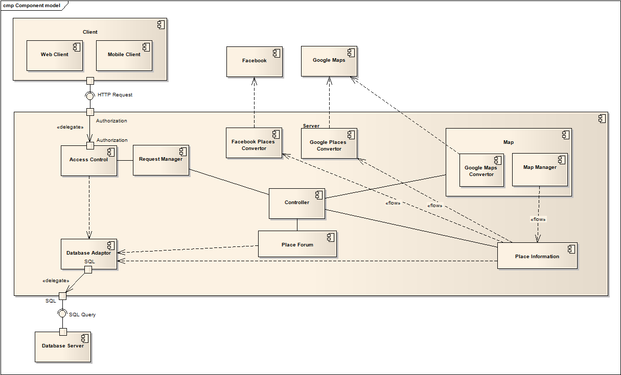
Fig 1.2 - Component diagram

Describe of Component diagram:
Client: Component that displays application output.
Server: Component that ensures application functionality.
Database server: Component that stores data.

Other components correspond to components in system architecture. Google Adaptor in system architecture contains Google Place Convertor and Google Maps Convertor. Model in system architecture contains Place Information, Place Forum and Map Manager. And Request and Response Aggregator contains Response Manager an Access Control. Relations between components are shown in picture.

Use Case Model

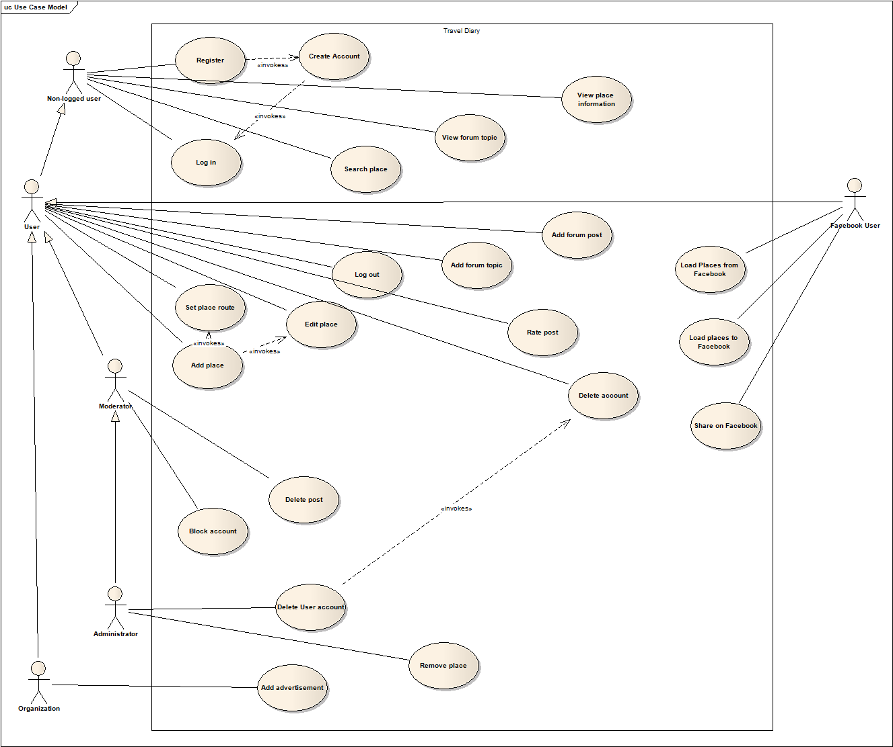
Fig 1.3 – Use Case Model

